Kansas City Watersports sold to investment group that includes Tony Finn, Marco Thompson

March 21st, 2011, Kansas City, Kansas - Cable park pioneer Mike Olson announced that he has sold Kansas City Watersports to an investment group. KCW was one of the first cable parks in the US. “I didn’t want to sell it to just anybody”, says Mike. “As a matter of fact, it wasn’t really on the market. However, I am focusing on a new Wake Nation Park in Houston and multiple other wake park projects around the country. At the same time, I wanted to keep the great tradition of KCW going. I called Tony, he called a few of his friends that love wakeboarding, and the deal was done. I will still be involved in helping them make KCW as good as it can be.”

Tony Finn, Founder of Liquid Force Wakeboards says “I love cables. I have ridden at countless cables around the world, and I always have a great time! Also, I love the fact that you don’t have to be rich to wakeboard on a cable. Riding wakeboards at cables is super fun and it opens up our sport to millions of people that wouldn’t normally be able to enjoy wakeboarding! I am really stoked to be involved in Kansas City. KCW has pioneered lots of cool things in the wakeboarding world. We will continue Mike’s great traditions such as the FOOLS FEST, which of course is on April Fools weekend, Relentless Weekend, Ladies Night, Student night, Beginners Night, etc… The more cable parks there are in the world the better!!” says a stoked Tony Finn

Serial Entrepreneur Marco Thompson is behind the investment group. His background includes one other cable park, 4 other action sports related businesses, and a total of 45 startup companies over the last 35 years. Marco is an avid boarder and adds “I wakeboard and wakesurf in San Diego 2 times a week. Our business vision is to help create 20 cable parks in the next 5 years, and 50 in the next 10 years. A chance to continue the Kansas City Watersports tradition was a great opportunity we couldn’t pass up”
Die Hard wakeboarder, Sean Hollonbeck will be running the park. Sean, who has managed both small and multimillion dollar businesses, looks forward to working in a field that he is passionate about. “This is a job that where you just can’t wait to get out of bed and get to work. I get to use my marketing background, and draw on the decades of business growth experience Marco brings, and the industry knowledge and enthusiasm that only Tony Finn can bring. I am also looking forward to reaching out to our local colleges and high schools, and running camps alongside our world class roster of PROs”.
Shelley Brown, an avid wakeskater, is Corporate Counsel for the new group, and brings business & legal expertise to the team.
Kansas City Watersports is a full service Cable Park in a beautiful setting 30 minutes from downtown Kansas City at 25825 Edgemore Road, Paola, KS 66071. We offer excellent riding for wakeboarders of all ages and abilities. We also have a full service pro shop offering a full suite of rental equipment and the latest 2011 Liquid Force gear for sale. KCW also has a snack shop, sand beach & a paintball facility, so you can show up and spend an entire day with us.
We are having our grand opening weekend during Fool’s Fest, starting Friday April 1st, and continuing thru Sunday April 3rd. During April, we will be open Friday through Sunday from noon -7PM, and 7 days a week starting May 23rd.

For more information go to our website, www.kcwatersports.com or join us on facebook at KC Watersports or twitter at kcwatersports. Or contact Sean Hollonbeck at sean@kcwatersports.com (303) 915-3535, or Marco Thompson at (619) 518-3001 marco@marcothompson.com
CU on the Water!!
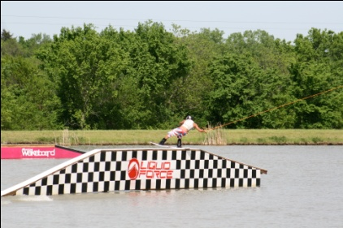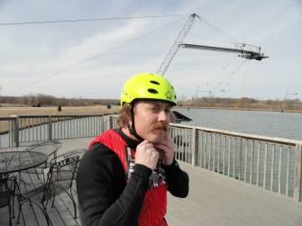
Liquid Force Rail at KCW KCW Owner Sean Hollonbeck gets ready to ride
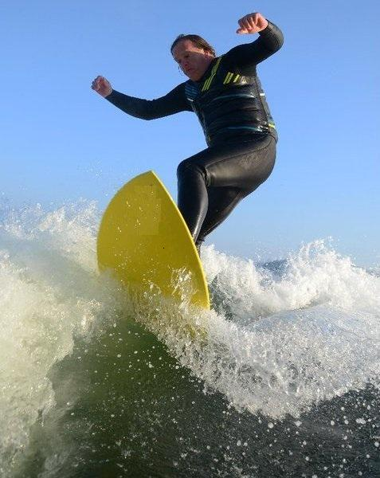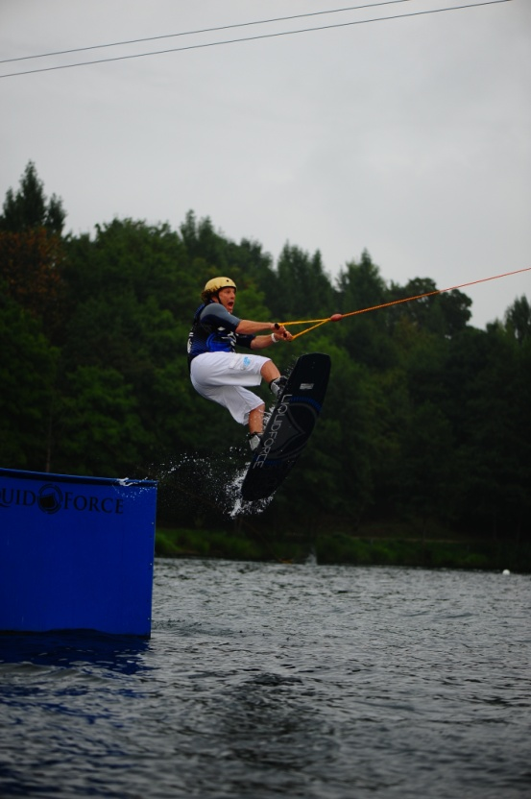
Investor Marco Thompson Tony Finn gets some air Wakeskating Lawyer . Wakesurfing at Wasserski Langenfeld Shelley Brown

